Project Risk Management Plan Template

Document No. EPM-EM0-TP-000002 Rev 00X

Engineer Review Status |  | Date: | Name:
 | A - Reviewed; Work may proceed
B - Reviewed with comments; Revise and resubmit;
Work may proceed subject to incorporation of comments
 | C - Objection - Revise and resubmit; Work may not proceed
 | D - Rejected
 | E - Review not required; Work may proceed

This Approval block will be removed once the document is “Issued for Use” as Revision 000

Document Submittal History:
Rev.: | Rev Status | Date: | Entity | Prepared by: | Checked by: | Reviewed by: | Approved by: | Authorization:
XXX | For XXX | dd/mm/yyyy | EXPRO | Name | Name | Name | Name | A AlAujan

THIS NOTICE MUST ACCOMPANY EVERY COPY OF THIS DOCUMENT
IMPORTANT NOTICE

This document, (“Document”) is the exclusive property of Government Expenditure & Projects Efficiency Authority.
This Document should be read in its entirety including the terms of this Important Notice. The government entities may disclose this Document or extracts of this Document to their respective consultants and/or contractors, provided that such disclosure includes this Important Notice.
Any use or reliance on this Document, or extracts thereof, by any party, including government entities and their respective consultants and/or contractors, is at that third party’s sole risk and responsibility. Government Expenditure and Projects Efficiency Authority, to the maximum extent permitted by law, disclaim all liability (including for losses or damages of whatsoever nature claimed on whatsoever basis including negligence or otherwise) to any third party howsoever arising with respect to or in connection with the use of this Document including any liability caused by negligent acts or omissions.
This Document and its contents are valid only for the conditions reported in it and as of the date of this Document.

Table of Contents

1.0 Purpose 5
1.1 Heading 2 5
1.1.1 Heading 3 5
2.0 Scope 5
3.0 definitions 5
4.0 References 5
5.0 Responsibilities 5
6.0 Process 5
7.0 Attachments 5
Attachment 1 - EXP-ID0-TP-000002 - Visio Template (Vertical) 6
Attachment 2 - EXP-ID0-TP-000003 - Visio Template (Horizontal) 7

Purpose and scope
[Note – this document is a template for the project risk management plan. It should be edited by the EPMOs for the purposes of applying it to an individual project. The convention adopted is that all text inside square brackets and in bold italics, provides guidance on the project risk management plan requirements to the EPMOs. It should be deleted and / or edited by the EPMO to reflect the specific project risk management arrangements that will be employed for the specific project. The project risk management plan will be a stand-alone document for each project.]
EXPRO requires each Entity Project Management Organization (EPMO) to develop a project risk management plan for every project that the EPMO is responsible for delivering.
The purpose of the risk management plan is to:
- specify clear roles and responsibilities for managing project risk
- define the project risk management process that will be employed by the EPMO for managing project risk
- define the project risk management reporting, escalation and governance arrangements that will be employed on the project
- specify the key project management interfaces with other processes and procedures
- define the project risk assessment methodology and the associated risk tolerance criteria that will be employed on the project.

The scope of the project risk management plan will be informed by the Project Delivery Strategy (EPM-S00-GL-000002) - which will define the project delivery strategy (e.g. the decision as to whether an engineering, procurement and construction (EPC) approach is preferred over a design and build approach). The project risk management plan will apply to all stages in the project life cycle – as defined by the EXPRO Stage Gate Process.
[Note – the project risk management procedure describes how risks will be considered at each stage in the Stage Gate Process.]
The project risk management plan will clearly identify any critical project management interfaces, and how these will be managed. For example, the link to the project controls management function will be described.
This project risk management plan will apply to THE PROJECT:
[Project title and Ministry cross reference numbers to be provided here.]
……………………………………………………………………………………………………………

It applies to project management services that will be delivered to THE CUSTOMER:
[Ministry name to be provided here.]
……………………………………………………………………………………………………………

By the following THE SUPPLIER:
[EPMO designated name or consultancy organization’s name to be provided here.]
……………………………………………………………………………………………………………

Terms and definitions
The project risk management procedure contains an extensive and comprehensive glossary of commonly used project risk management terms and definitions. These are not repeated here.

Key project management interfaces
The project risk management activities that will be undertaken to comply with the project risk management procedure, and in accordance with this project risk management plan, will be informed by the Project Execution Plan.
The project risk management activities apply to all stages of the project life cycle – as defined in the Stage Gate Process.
Outputs from execution of the project risk management plan will feed into the Project Controls processes for the Trend Program process and the Critical Items Action Reporting process.

References
Key references cited in this plan are as follows:
- EPM-EM0-PR-000001 - Project Risk Management Procedure.
- EPM-EM0-TP-000001 - Project Risk Register Template.
- EPM-S00-GL-000002 - Project Delivery Strategy.
- EPM-EQ0-PR-000001 - Project Stage Gate Procedure.
- EPM-KPC-PR-000007 - Project Trend Program Procedure.
- EPM-KPR-PR-000005 - Project Critical Items Action Report Procedure.

Roles and responsibilities
In this section the key roles associated with managing and executing the risk management plan will be identified and the responsibilities of each key role described.
A named individual MUST be provided for the Project Manager role before the project risk management plan can be issued.
As the project risk management plan is developed, then other roles may have names allocated to them but this will be at the direction of the Project Manager. Over the whole project life cycle then named individuals against specific roles will change. A register of these named individuals shall be maintained at the direction of the Project Manager which will capture the historical record of all changes in key roles.
[The following list of key roles will be required as a minimum.
The project risk management procedure provides a template description of the specific responsibilities that each of these key roles will be expected to fulfill. Brief summaries of these specific responsibilities are provided here but the procedure should be referred to for the fuller descriptions.]

Project Manager
- To provide overall direction for the project, including project risk management activities
- To support all internal and external interface and resource requirements.

Risk Manager
- To support the Project Manager by managing the project risk management process
- To engage with all internal and external stakeholders and facilitate all communication requirements
- To manage the interfaces with all other relevant project management processes
- To maintain the project risk register and facilitate all data collation in support of this.

5.3 Project Team
- To participate in and contribute to the execution of the project risk management process throughout the complete project life cycle

[Note –membership of the project team will vary according to the specific project life cycle stage – as defined by the stage gate process. The Risk Manager will recommend project team membership, but membership will be determined by the Project Manager.]
- To provide expert input on the allocation of Risk Owners for all identified project risks
- To provide guidance and expert input on any decisions about risk management intervention options.

Risk Owner
- These are nominated by the project team against individual risks, and approved by the Project Manager
- Responsible for the management of any risks allocated to them – and are answerable to the Project Manager
- Provide suggestions to the project team on the risk management interventions that could be employed to help manage specific risks.

Risk Treatment Owners
- These are nominated by the Risk Owner
- Responsible for the implementation and execution of agreed risk management interventions - and are answerable to the Risk Owner
- Responsible for monitoring and reporting effectiveness of the risk management interventions that they are responsible for.

Process
The project risk management process that will be followed is fully described in the project risk management procedure (EPM-EM0-PR-00001). A schematic representation of this process is reproduced in the following overview for information and cross reference.
All project risks will be recorded in the project risk register in accordance with the requirements described in the project risk management procedure. A template risk register has been developed for this purpose (Project risk register template: EPM-EM0-TP-000001), and an example of this is presented in Attachment 1.

Overview of the Process

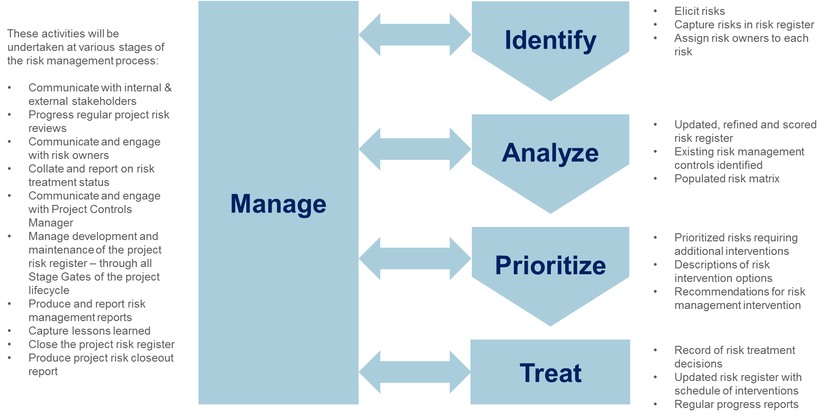
Overview of the Project Risk Management Process

The steps in the project risk management process are:
- Identify risks via risk elicitation, draft their risk statements, and assign Risk Owners. All risks will be captured in a project risk register.
- Analyze risks through an examination and documentation of causes and effects, categorize the risks by their sources, and determine potential impact dates.
- Prioritize risks based on estimation of likelihood and impacts, determine the current risk ranking on the risk matrix, and recommend risk management intervention options based on its risk priority.
- Treat risks where the risk management interventions are judged to be practicable and result in tolerable residual risk, regularly evaluate the effectiveness of these risk treatments.
- Manage risks by undertaking regular monitoring and review activities, ensuring project risk register data quality, ensuring alignment with functional interfaces, executing risk response plans, providing reports and metrics, transferring risks to the Trend program and Critical Items Action Reporting program, closing risks, and completing lessons learned.

These process steps will be performed in accordance with the project risk management procedure.

Governance Arrangements
The project risk management activities that are managed and overseen by the Risk Manager will be undertaken according to a predetermined management cycle that will be agreed and approved by the Project Manager.
These are recorded here:
[The following table provides an example of this cycle but the actual timings will be specified for each project.]
Prior to: | Activity [edit table as appropriate]
1st of the Month | - Risk owners review their risks for update and action using reports and metrics provided by the Risk Manager
2nd to 22nd of each Month | - Risk manager, Risk Owners and other risk stakeholders update risks in the project risk register, and evaluate risk response plans as required by risk review requirements  - From stakeholder discussions, consideration is given to the potential for new risks for consideration by the project management team at the monthly risk meeting, or sooner if a high-level risk is foreseen
23rd of each Month | - The risk register is frozen at month-end for report development and for a copy to be archived
25th of each Month | - The Risk Manager issues reports and metrics to the Project Manager, project team (or project risk review group), Risk Owners, and other stakeholders (e.g. the customer)  - Risk manager ensures data archival requirements are complied with
28th of each Month | - The monthly project risk review meeting is held with the project team (or project risk review group)
Quarterly | - Project team (or project risk review group) undertake a full review of the project risk register  - Review of overall effectiveness of project risk management plan and associated activities with the project management team
Semi-Annually | - Project risk identification workshop with the project team (or project risk review group) and other risk stakeholders  - Health check of project risk management process, either as part of Stage Gate Process, by the project team (or project risk review group), or independently initiated

[Other Governance Arrangements]
In addition to the roles described above, there may be specific governance arrangements that the EPMO will want to include for monitoring and reviewing project risk. These governance arrangements will be described here. For example, depending on the scale and complexity of the project, a separate Project Risk Review Group may be established. Alternatively, project risks may be reviewed as a standing item on the agenda for an overall Project Review Group.
The customer may specify these governance arrangements or they may be determined by the Project Manager – in consultation with the customer. The Risk Manager will advise the Project Manager on the membership of any project risk review group. For example, it would be good practice for the project controls manager to be a member of any project risk review group so that the transfer of any ‘trends’ from the project risk register to the project controls function is undertaken in an integrated and seamless manner.
The project risk management plan will describe these governance arrangements. It will describe the terms of reference for any review group, which will indicate: what its role and responsibility will be; who will be represented on it; how often it will meet; what information it will review; what decisions it will make; and what authority it will have.]

Project risk assessment methodology
Project risks will have their impacts and likelihoods (probability) assessed or rated according to the scheme described below. Project risks will then be mapped onto the project risk matrix according to the combination of impact and likelihood. Priorities for risk management interventions will be determined according to the method and tolerance criteria described in Section 7.3.
[Cost and Time will be edited on a bespoke basis and to match project scale. The other dimensions should not be changed.]

Project Risk Impact and Likelihood Categories
Project Risk Impact Rating Scheme
Impact Category | A  Very Low | B  Low | C  Medium | D  High | E  Very High
Cost | [Project Specific  e.g. < 1% of budget] | [Project Specific  e.g. 1-5% of budget] | [Project Specific  e.g. 5-10% of budget] | [Project Specific  e.g. 10-25% of budget] | [Project Specific  e.g. > 25% of budget]
Time | [Project Specific  e.g. < 1 month delay] | [Project Specific  e.g. 1-3 months delay] | [Project Specific  e.g. 3-6 months delay] | [Project Specific  e.g. 6-12 months delay] | [Project Specific  e.g. > 12 months delay]
Safety | First aid or slight injury/illness with no treatment. | Recordable, medical treatment, restricted work, temporary effect. | Lost time injury/illness or permanent disability. | Single fatality or permanent disability of 3 or more persons. | Multiple fatalities.
Quality | Defects in work identified. Minor corrective action contained within operational role in that shift. Insignificant impact, fully contained. Minor productivity impact. | Defective work identified. Corrective action spanning multiple shifts required. Minor schedule and cost impact. Schedule recoverable. | Systemic defective work produced & identified prior to operational testing. Multiple corrective actions required over many days. Moderate schedule impact or knock on effect on delaying subsequent work activity by a number of days & up to $50k cost impact to business. | Defective work not identified until operational testing. Single corrective actions spanning multiple weeks. Significant impact. Risk of lost time incident in operational testing. Multiple weeks delay to schedule and up to $1M cost impact to business. | Systemic defective work produced & not identified until operational testing. Multiple corrective actions required spanning months. Catastrophic impact, risk of employee fatality in operational testing, Multiple months impact on schedule & multi-$M cost impact to business.
Environmental | Insignificant impact. fully contained. | Negligible short-term impact, confined on site, no regulatory exceedance. | Moderate to significant impact confined on site, regulatory exceedance, or any off-site impact. | Significant impact on or off site, or potential enforcement action. | Catastrophic impact, long-term liability, or irreversible damage.

Community | Little or no complaint(s) to site and/or regulator from abutters, local stakeholder groups or local government. | Minor complaint(s) from abutters, local stakeholder groups or local government. | Significant complaint(s) from abutters, local stakeholder groups or local government. Isolated, small-scale protest. | Persistent complaints from community and national stakeholder groups or national government. Large-scale protests. Threat of legal action. | Community/NGO legal action. Significant concerns expressed by key international stakeholder groups or from more than one national government. Sustained large-scale protests with injury or damages.
Reputation | No negative media coverage. No disruptions in current operations. | Local negative media coverage. Some limits on current operations. | Regional negative media coverage. Disruptive impact on current operations. Issue creates complications with customer relationship. | Sustained negative regional or national media coverage. Significant and/or sustained impact on project progress/current operations. Issue creates significant customer conflict. | Influential national or international negative media coverage. Significant impact on project delivery for months. Customer publicly states dissatisfaction with EPMO. Significant legal action.
Security | A threat exists against the asset or a person. A willful criminal act or condition resulting in a Category I impact. Normal management action required. | A threat exists against the asset or a person. A willful criminal act or condition resulting in a Category II impact. Normal management action required. Low level of external emergency service assistance may be required. | A threat exists against the asset or a person. A willful criminal act or condition resulting in one or more Category III impacts. External emergency service assistance may be required. | A threat exists against the asset or persons. A willful criminal act or condition resulting in one or more Category IV impacts. External emergency service assistance is required. | A threat exists against the asset or persons. A willful criminal act or condition resulting in one or more Category V impacts. Multiple external emergency services assistance is required.

Risk Likelihood Categories
Project Risk Likelihood (Probability) Rating Scheme
Category | A  Rare | B  Unlikely | C  Possible | D  Likely | E  Almost Certain
Likelihood | Risk has an occurrence of less than 1% in the relevant industry. | Risk is unlikely to occur on this project with current processes and procedures in place. | Risk occurs often within the industry or Company. | Risk has recently occurred on a similar project within the industry or Company. | Risk is highly likely to occur on this project, potentially multiple times.
Probability | < 10% | 10% to 30% | 30% to 70% | 70% to 90% | > 90%
(Note - only likelihood OR probability will be used, never both at the same time.)

Project Risk Tolerance Criteria
The project risk profile will be determined by mapping all project risks identified in the project risk register onto a 5 × 5 risk matrix as illustrated below. Each risk will be mapped onto the risk matrix according to its impact and likelihood combination.
The individual cells of the risk matrix have been allocated to a risk matrix category that is color coded (red, amber, yellow, green) and prioritized numerically according to the scheme prescribed in the following Risk Matrix.
Note the numbers are assigned for prioritization purposes only. They are not derived from any numerical calculation.
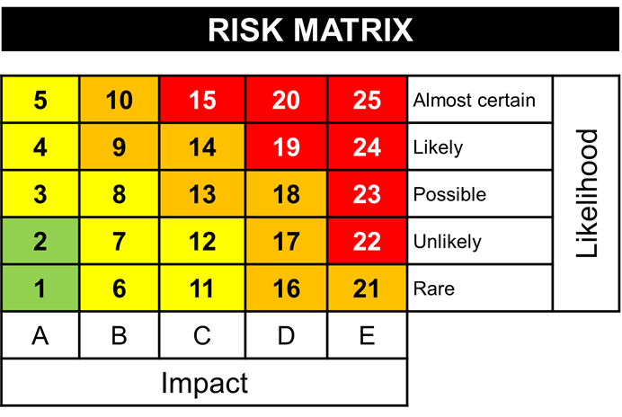

The project risk tolerance criteria that will be applied to risks mapped onto the risk matrix is specified here along with the project risk management response that will be applied.
 | Risk Matrix Category
 | Red  Priority 1 | Amber  Priority 2 | Yellow  Priority 3 | Green  Priority 4
Risk Tolerance | Risks that significantly exceed the risk tolerance threshold | Risks that exceed the risk tolerance threshold | Risks that lie on the risk tolerability threshold | Risks that are below the risk tolerability threshold
Risk Response | Requires urgent and immediate attention | Requires proactive management | Requires active monitoring | Do not require active management

Attachments
- EPM-EM0-TP-000001 - Project Risk Register Template

Attachment 1 - EPM-EM0-TP-000001 - Project Risk Register Template

